DELIVERY LOGISTICS

Business Analytics Dashboard — India Multi-Partner Logistics Dataset

Author: Hrishav Hari
Type: Data Analytics Internship Project
Dataset: Delivery Logistics Dataset — India Multi-Partner
Records: 25,000 rows × 15 columns
Date: September 2026

1. Executive Summary
This report presents the findings of a comprehensive business analytics study conducted on the India Multi-Partner Delivery Logistics dataset, comprising 25,000 delivery records across nine logistics partners, five geographic regions, and four delivery modes.
The network achieved an overall on-time delivery rate of 73.3%, with 21.4% of deliveries classified as delayed and 5.3% failing outright. The average delivery cost across the network stood at ₹864.94, with an average customer satisfaction rating of 3.67/5.
Measurable performance variation was observed across delivery partners, geographic regions, delivery modes, vehicle types, and weather conditions. The analysis identifies five key operational risks and five practical management actions, all grounded in verified data.

2. Business Problem & Objectives
Management requires data-driven answers to the following operational questions:
- How many deliveries are being processed and what is the overall on-time rate?
- Which logistics partners deliver the best and worst on-time performance?
- Which regions experience the highest delay and failure concentrations?
- How does delivery cost vary across partners, modes, distances, and weights?
- How do customer ratings correlate with delivery performance dimensions?
- What operational risks exist and what actions should management consider?

3. Dataset Overview
Source: Kaggle — Delivery Logistics Dataset, India Multi-Partner
URL: https://www.kaggle.com/datasets/muhammadahmaddaar/delivery-logistics-dataset-india-multi-partner

Property | Value
Total Records | 25,000
Columns | 15
Exact Duplicates | 0
Missing Values | 0
Delivery Partners | 9
Regions | 5
Delivery Modes | 4
Vehicle Types | 6
Package Types | 9
Weather Conditions | 6
Date Range | No calendar dates (cross-sectional dataset)

4. Technology Stack
Technology | Purpose
Python 3.8+ | Core programming language
Pandas | Data loading, cleaning, aggregation
NumPy | Numerical computations, feature engineering
Plotly | Interactive dashboard charts
Streamlit | Dashboard frontend framework
Matplotlib | Static chart generation for this report
python-docx | Word report generation

5. Data Understanding, Cleaning & Validation

5.1 Raw Data Observations
- 25,000 records with 15 columns — no missing values across all columns.
- delivery_id contains 498 non-unique values; treated as a reference field, not a primary key.
- delivery_time_hours and expected_time_hours are stored as nanosecond-epoch timestamp strings (e.g., '1970-01-01 00:00:00.000000008'); decoded to integer hours using fractional nanosecond extraction.
- All categorical columns use consistent lowercase values with no mixed-case inconsistencies.
- No exact duplicate rows detected.

5.2 Cleaning Pipeline
- Load raw CSV → standardise column names to snake_case lowercase.
- Strip and lowercase all categorical string columns.
- Decode nanosecond-epoch time strings → integer hours for delivery_time_hours and expected_time_hours.
- Enforce numeric types for distance_km, package_weight_kg, delivery_cost, delivery_rating.
- Validate numeric ranges: cost > 0, distance > 0, weight > 0, rating between 1 and 5.
- Audit duplicate records and non-unique delivery_id values.

5.3 Data Quality Summary
Check | Value | Status
Raw rows | 25,000 | PASS
Raw columns | 15 | PASS
Exact duplicates | 0 | PASS
Missing values (all columns) | 0 | PASS
Invalid delivery_time_hours | 0 | PASS
Invalid expected_time_hours | 0 | PASS
Invalid delivery_cost (≤0) | 0 | PASS
Invalid distance_km (≤0) | 0 | PASS
Invalid delivery_rating | 0 | PASS
Non-unique delivery_id rows | 498 | INFO
Overall Data Quality | PASS | PASS

6. Feature Engineering
The following derived columns were created from verified source columns:
Feature | Formula | Business Purpose
time_gap_hours | delivery_time_hours − expected_time_hours | Measures how early (negative) or late (positive) a delivery arrived relative to expectation.
cost_per_km | delivery_cost / distance_km | Unit delivery cost per kilometre — useful for route efficiency analysis.
cost_per_kg | delivery_cost / package_weight_kg | Unit delivery cost per kilogram — useful for weight-based cost benchmarking.
distance_band | Cut: Short (0–100), Medium (100–200), Long (200–300 km) | Groups deliveries into distance tiers for segment analysis.
weight_band | Cut: Light (0–17), Medium (17–33), Heavy (33–51 kg) | Groups packages into weight tiers.
performance_category | Mapped from delivery_status: On-Time / Delayed / Failed | Human-readable performance label for visualisations.
rating_band | Cut: Low (1–2), Medium (3), High (4–5) | Aggregated rating tier for segment comparisons.
is_on_time | 1 if delivery_status == 'delivered', else 0 | Binary flag for aggregation.
is_delayed | 1 if delayed == 'yes', else 0 | Binary flag for aggregation.
is_failed | 1 if delivery_status == 'failed', else 0 | Binary flag for aggregation.

7. KPI Framework & Results
All KPIs are calculated from verified, cleaned data. No values are fabricated.

25,000  Total Deliveries | 73.3%  On-Time Delivery % | 21.4%  Delayed Delivery %
5.3%  Failed Delivery % | 6.25 hrs  Avg Delivery Time | 13.11 hrs  Avg Expected Time
₹864.94  Avg Delivery Cost | ₹21.62M  Total Delivery Cost | ₹7.04  Avg Cost per KM
₹81.74  Avg Cost per KG | 3.67/5  Avg Customer Rating

8. Overall Delivery Performance
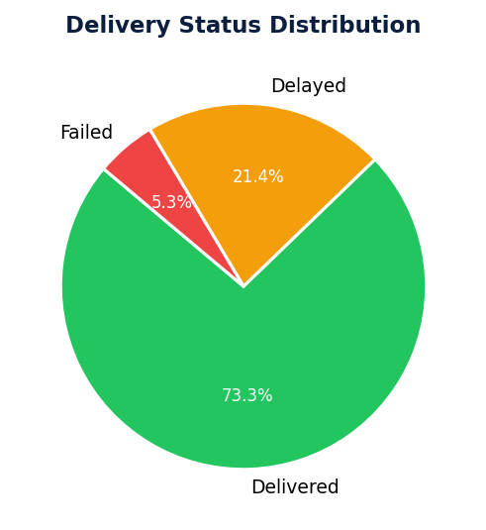
Figure 1 — Delivery Status Distribution
The network processed 25,000 deliveries. 73.3% were delivered on time, 21.4% were delayed, and 5.3% failed outright.

9. Logistics Partner Analysis
On-time delivery rates vary across the nine logistics partners. Delhivery recorded the highest on-time rate at 75.2%, while Xpressbees recorded the lowest at 71.7%, representing a 3.5 percentage-point spread.
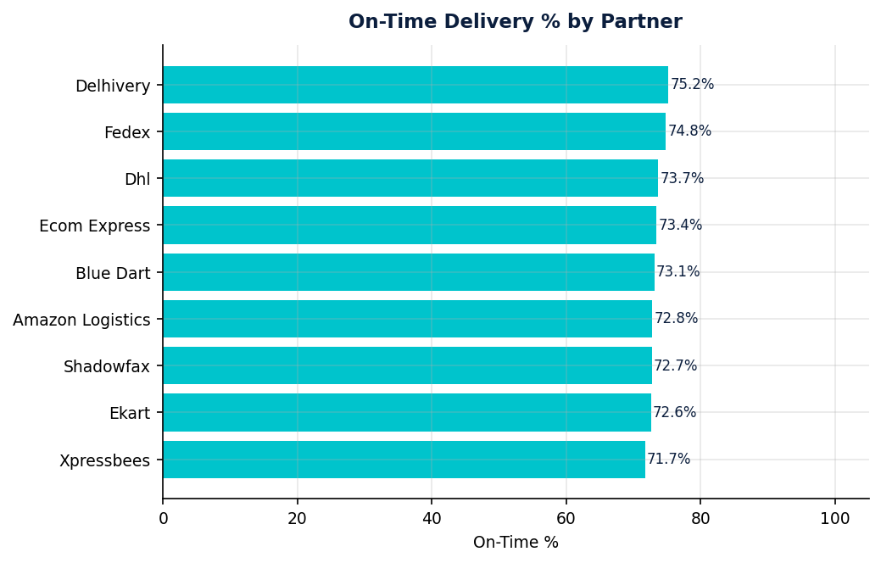
Figure 2 — On-Time Delivery % by Partner
Partners are ranked from lowest to highest on-time rate. The gap between top and bottom partner represents a measurable operational variance across the network.

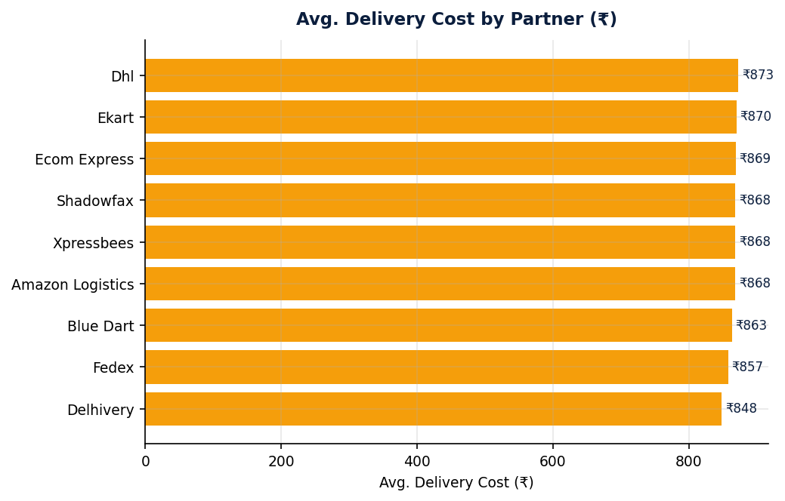
Figure 3 — Avg. Delivery Cost by Partner (₹)
Dhl is the highest-cost partner at ₹873 avg., compared to Delhivery at ₹848 avg.

10. Regional Performance Analysis
The Central region recorded the highest delay rate at 27.3%, while the East region observed the lowest at 25.8%. This 1.5 pp differential suggests regional operational variation worth investigating.
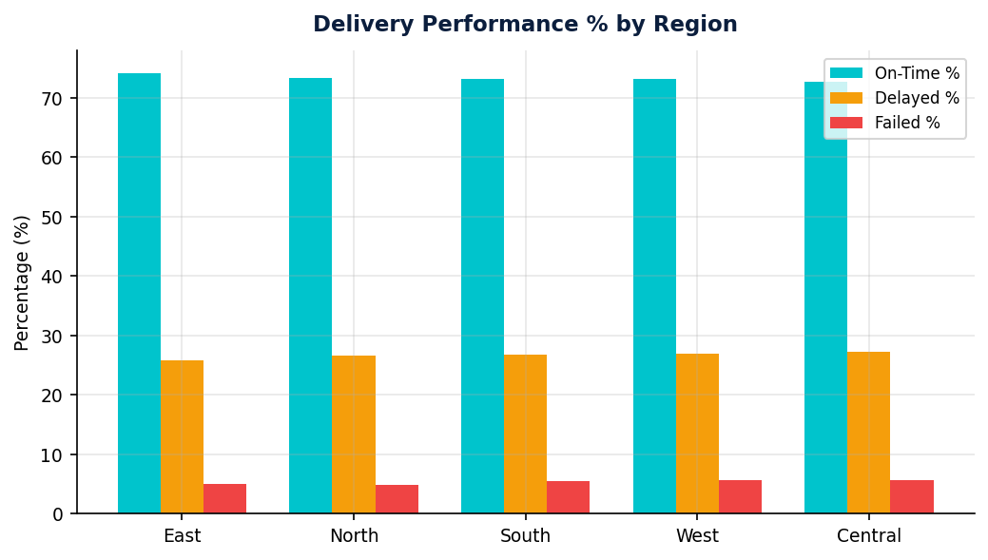
Figure 4 — Delivery Performance % by Region
On-time, delayed, and failed percentages are compared across all five regions.

11. Weather Condition Analysis
Stormy conditions are associated with the highest observed delay rate (41.4%), compared to Cold conditions at 16.0%. No causal relationship is claimed — weather appears as an observable factor associated with delivery variability.
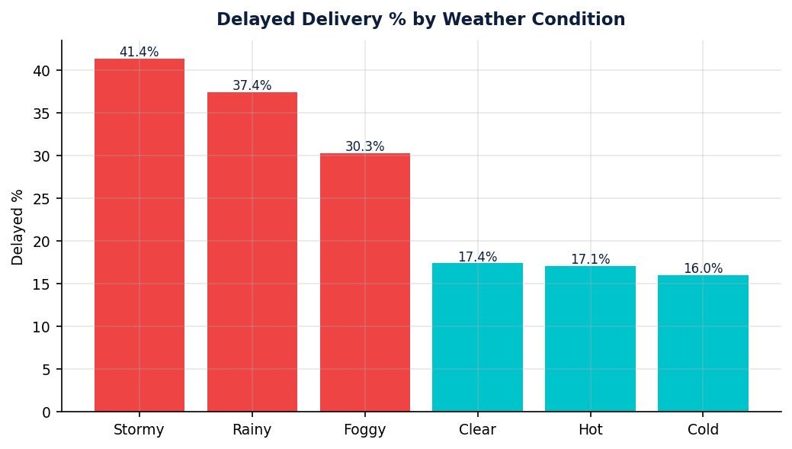
Figure 5 — Delayed Delivery % by Weather Condition
Bars coloured red indicate delay rates above 30%; amber above 20%.

12. Cost & Efficiency Analysis
The average delivery cost across the network is ₹864.94, with a total network cost of ₹21.62M. Cost per km averages ₹7.04 and cost per kg averages ₹81.74.
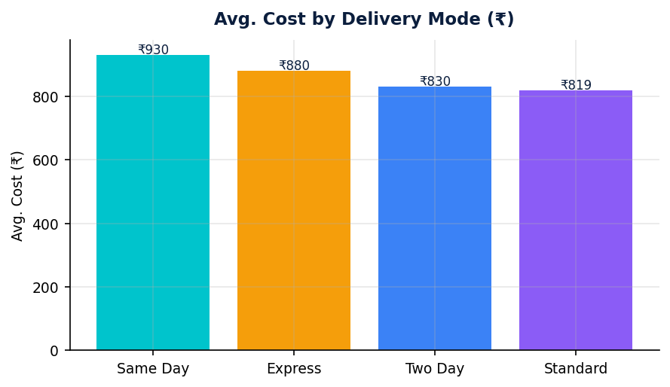
Figure 6 — Avg. Delivery Cost by Mode (₹)
Delivery mode cost comparison across express, same-day, standard, and two-day modes.

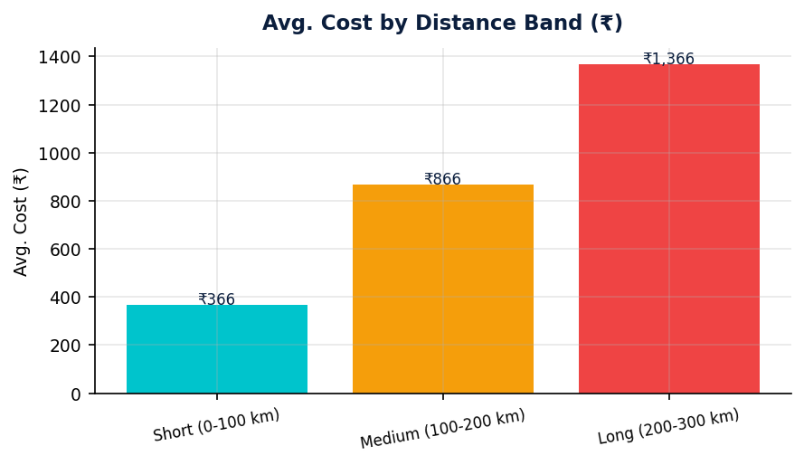
Figure 8 — Avg. Cost by Distance Band (₹)
Cost increases with distance, confirming the expected cost-distance relationship.

13. Customer Experience Analysis
The average customer rating across the network is 3.67/5. 14,705 deliveries (58.8%) received a high rating (4–5★), while 4,522 (18.1%) received a low rating (1–2★).
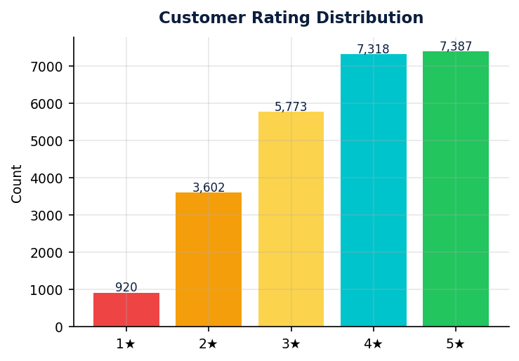
Figure 7 — Customer Rating Distribution
The majority of ratings cluster at 4–5 stars, indicating generally positive customer experience.

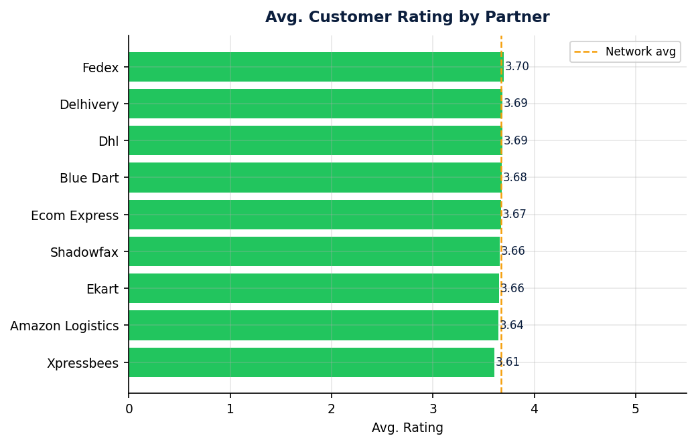
Figure 9 — Avg. Customer Rating by Partner
Rating variation across partners; the dashed amber line marks the network average.

14. Risk Analysis
All risks are grounded in verified, observable data. No speculative claims are made.

HIGH DELAY REGION — Central region: 27.3% delay rate vs network avg of 21.4%.

PARTNER PERFORMANCE GAP — Xpressbees: 71.7% on-time rate vs network avg of 73.3%.

WEATHER SENSITIVITY — Stormy conditions: 41.4% delay rate. No contingency protocols documented.

FAILED DELIVERY RATE — 5.3% outright failure rate (1,328 deliveries). Each failure represents lost revenue and potential customer churn.

COST CONCENTRATION — Dhl averages ₹873 per delivery vs network avg of ₹865.

15. Opportunity Analysis
PARTNER BENCHMARKING — 75.2% vs 71.7% on-time rate gap. Transferring Delhivery's practices could lift network performance.

COST REDUCTION — ₹25 spread between highest and lowest cost partner. Renegotiation or reallocation opportunity identified.

REGIONAL FOCUS — East region achieves 74.2% on-time rate. Investigating contributing factors could inform improvements elsewhere.

16. Recommended Actions
1 | Review allocation of delivery volume to Xpressbees and implement a performance improvement plan with measurable on-time delivery targets.

2 | Conduct a root-cause investigation into elevated delay and failure rates in the Central region — evaluate partner assignment, route planning, and capacity.

3 | Develop weather-contingency protocols for Stormy conditions, including pre-emptive customer communications and rescheduling workflows.

4 | Benchmark the operational practices of Delhivery (on-time: 75.2%) and evaluate applicability across the partner network.

5 | Prioritise cost-per-km analysis for the highest-cost partner (Dhl: ₹873) to identify route or pricing inefficiencies.

17. AI Executive Analyst
The following findings, risks, opportunities, and actions were generated by a deterministic AI Executive Analyst module. All statements are based exclusively on verified, pre-calculated metrics. No numbers are fabricated. No causal claims are made without data support.

Key Findings
- The network processed 25,000 deliveries with an overall on-time delivery rate of 73.3%, while 21.4% were delayed and 5.3% failed.
- Among logistics partners, Delhivery recorded the highest on-time rate at 75.2%, compared to Xpressbees at 71.7%.
- The Central region observed the highest delay concentration at 27.3%, while East performed best at 25.8% delay rate.
- Deliveries associated with Stormy conditions recorded a higher delay rate (41.4%) compared to Cold conditions.
- Average delivery cost stood at ₹864.94, with Dhl averaging the highest cost (₹872.83) and Delhivery the lowest (₹848.11).

Operational Risks
- Concentration of delays in Central region (27.3%) warrants priority monitoring.
- Performance gap between best and worst partner represents a 3.5 pp spread — a significant risk if volume concentrates in lower-performing partners.
- Stormy weather is associated with 41.4% delay rate. Adverse weather periods pose a recurring service risk.

Opportunities
- The 3.5 pp on-time gap between best and worst partner represents a benchmarking opportunity.
- ₹25 cost spread between highest and lowest cost partner indicates a renegotiation or reallocation opportunity.
- The East region achieves 74.2% on-time rate — investigating contributing operational factors could lift network performance.

18. Dashboard Overview
The interactive Streamlit dashboard is organised into five pages, all responding to seven global sidebar filters (Partner, Region, Delivery Mode, Vehicle Type, Weather Condition, Package Type, Delivery Status).
Page | Contents
🏠 Operations Command Center | 3 headline KPI cards (On-Time %, Avg Delivery Time, Avg Cost), 4 supporting metrics, status donut chart, partner stacked bar chart, region/mode overview, executive observations.
📊 Delivery Performance | Partner performance grouped bar, avg delivery time ranking, regional on-time/failed bars, vehicle type performance, weather delay analysis, delivery mode comparison.
💰 Cost & Efficiency | 4 cost KPI cards, partner cost rankings, cost/km comparison, mode/region cost bars, distance band cost analysis, cost-distance scatter, weight band cost, partner×mode heatmap.
⭐ Customer Experience | 3 rating KPIs, rating distribution (donut + bar), partner/region/mode/package type/vehicle rating comparisons, performance category vs rating.
⚠️ Risk & Opportunities | 5 risk cards (colour-coded by severity), 4 opportunity cards, 5 recommended action items, AI Executive Analyst section with findings/risks/opportunities, data quality status table.

Visual Design Identity
The dashboard uses an "Ops Terminal" visual identity: deep navy (#0B1E3D) sidebar, off-white (#F5F7FA) main canvas, electric teal (#00C4CC) accent colour, amber warning indicators, and red risk markers. All-caps section headers with teal left-border separators, borderless KPI cards with status pills, dark insight panels, and severity-coded risk cards create a professional, operations-grade interface distinct from generic reporting dashboards.

19.Result
User Interface:
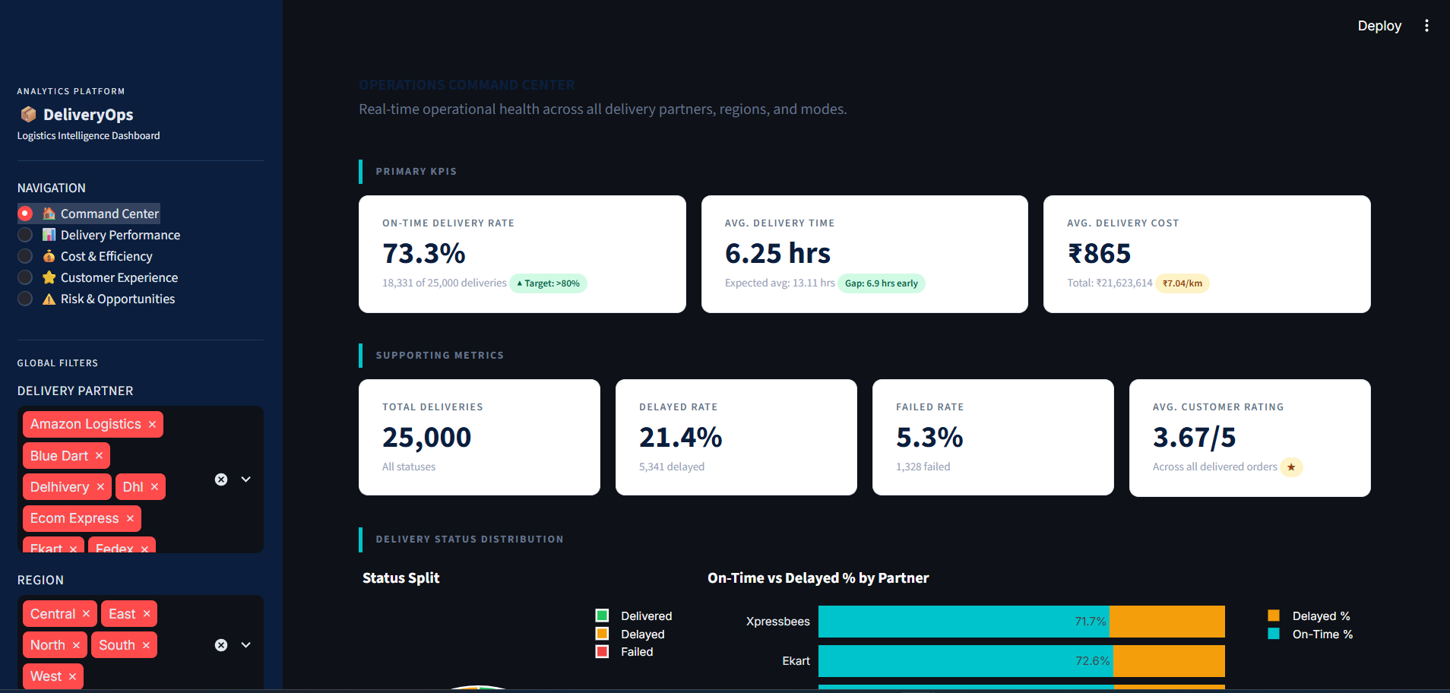Picture 1:Main Page
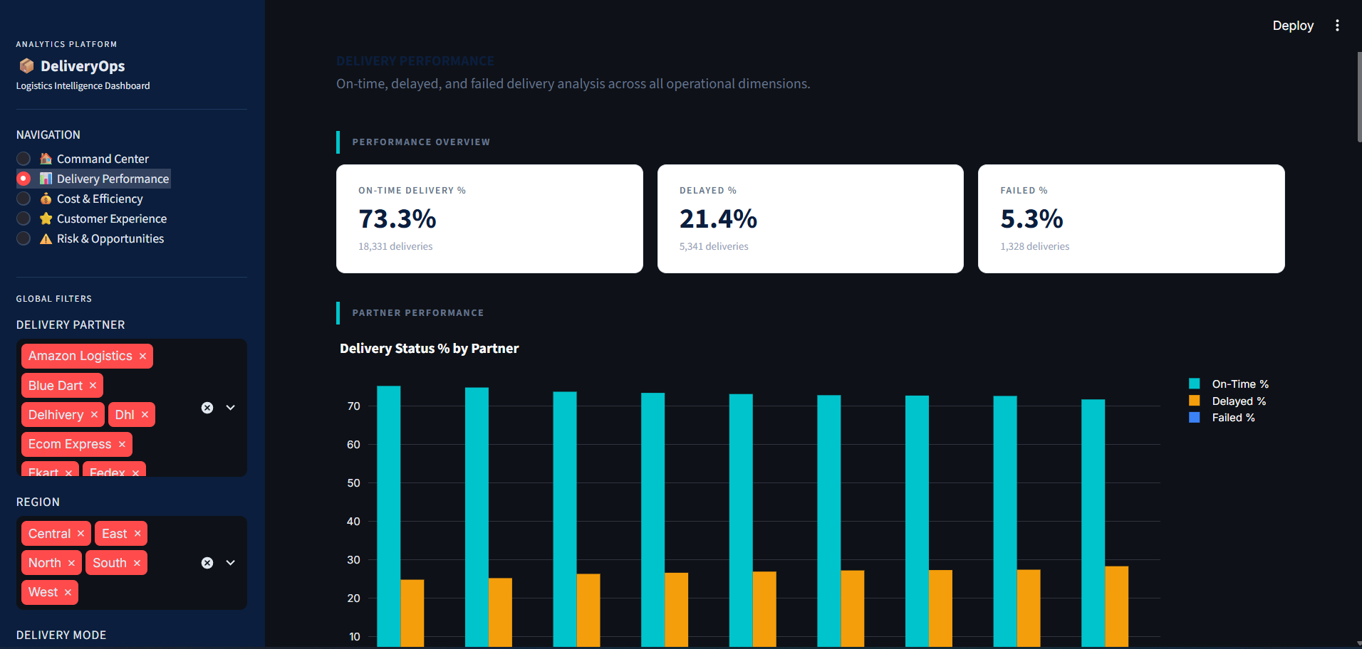
Picture 2: Delivery Performance 1
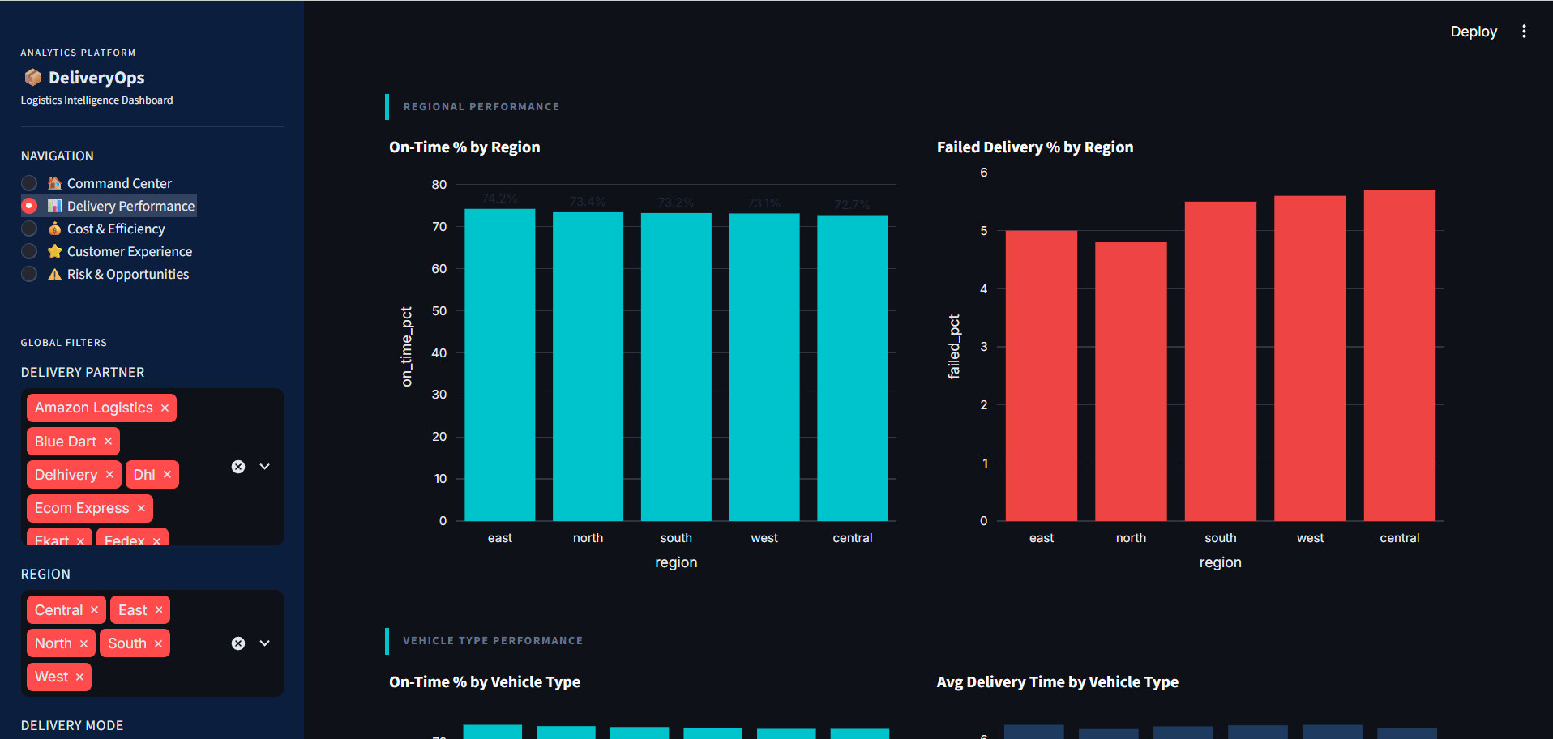
Picture 3: Delivery Performance 2

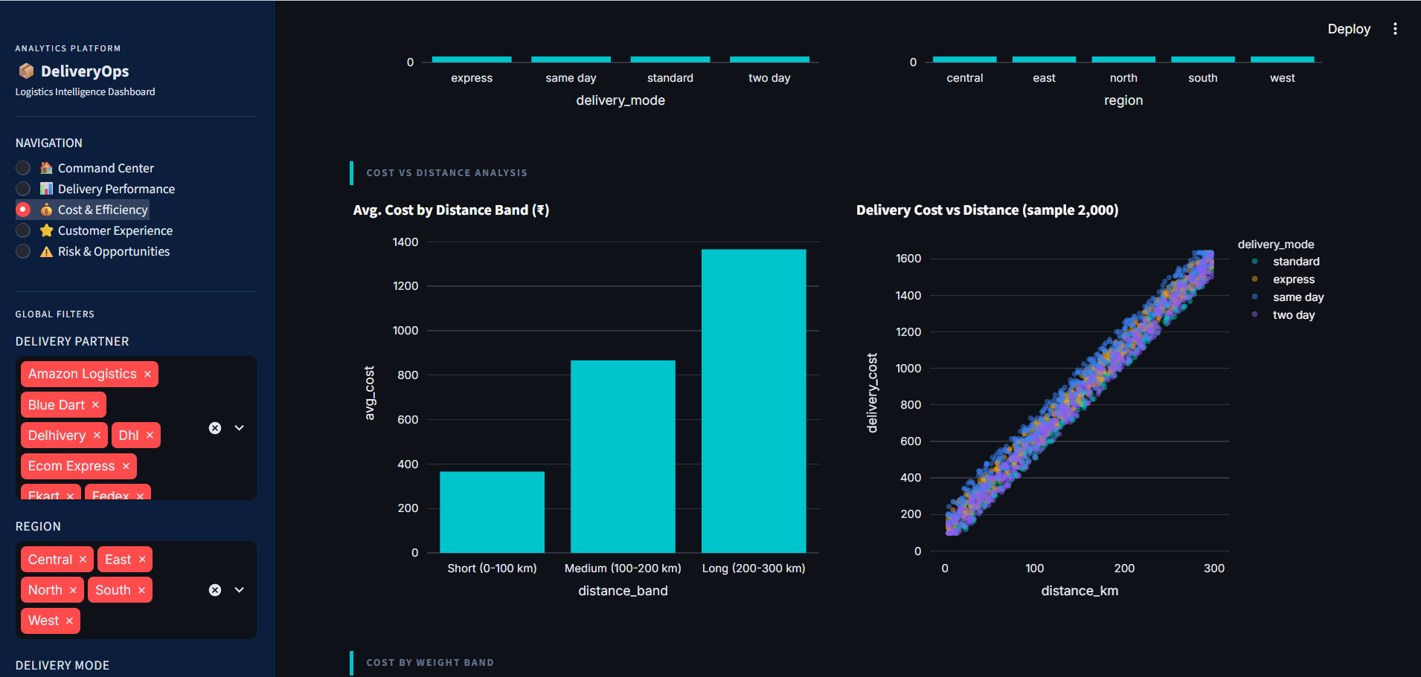
Picture 4: Cost & Efficiency
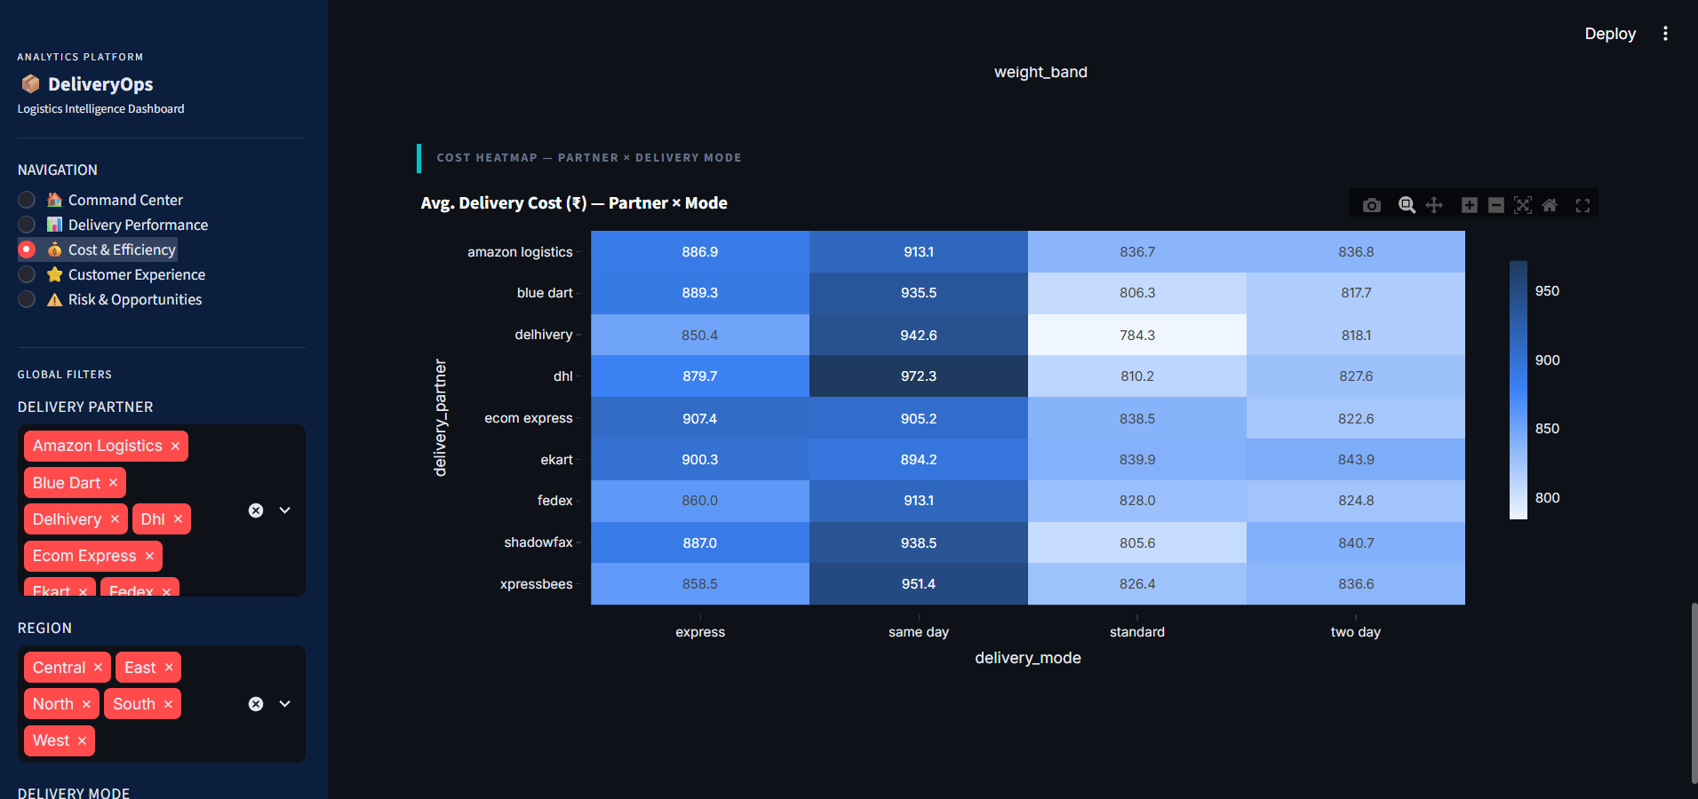
Picture 5: Heatmap,Cost & Efficiency
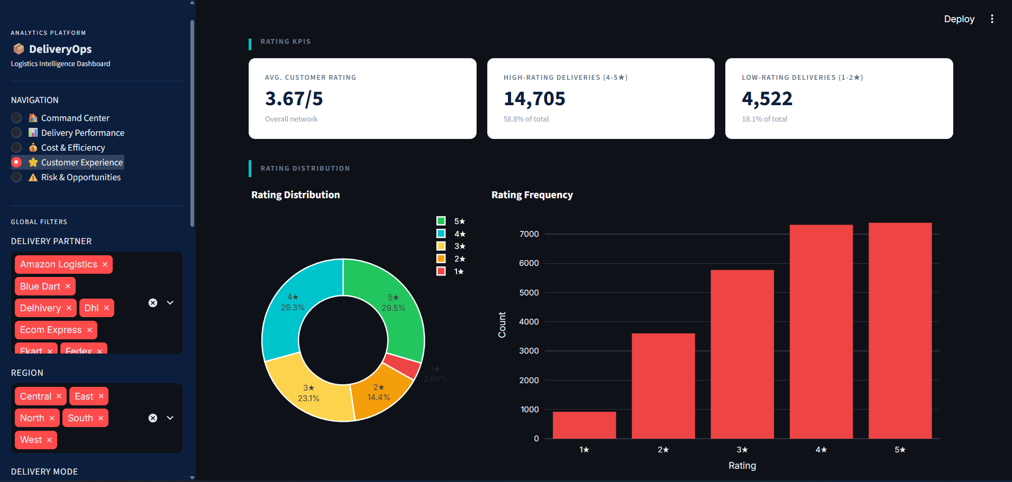
Picture 6: Rating Distribution , Customer Experience
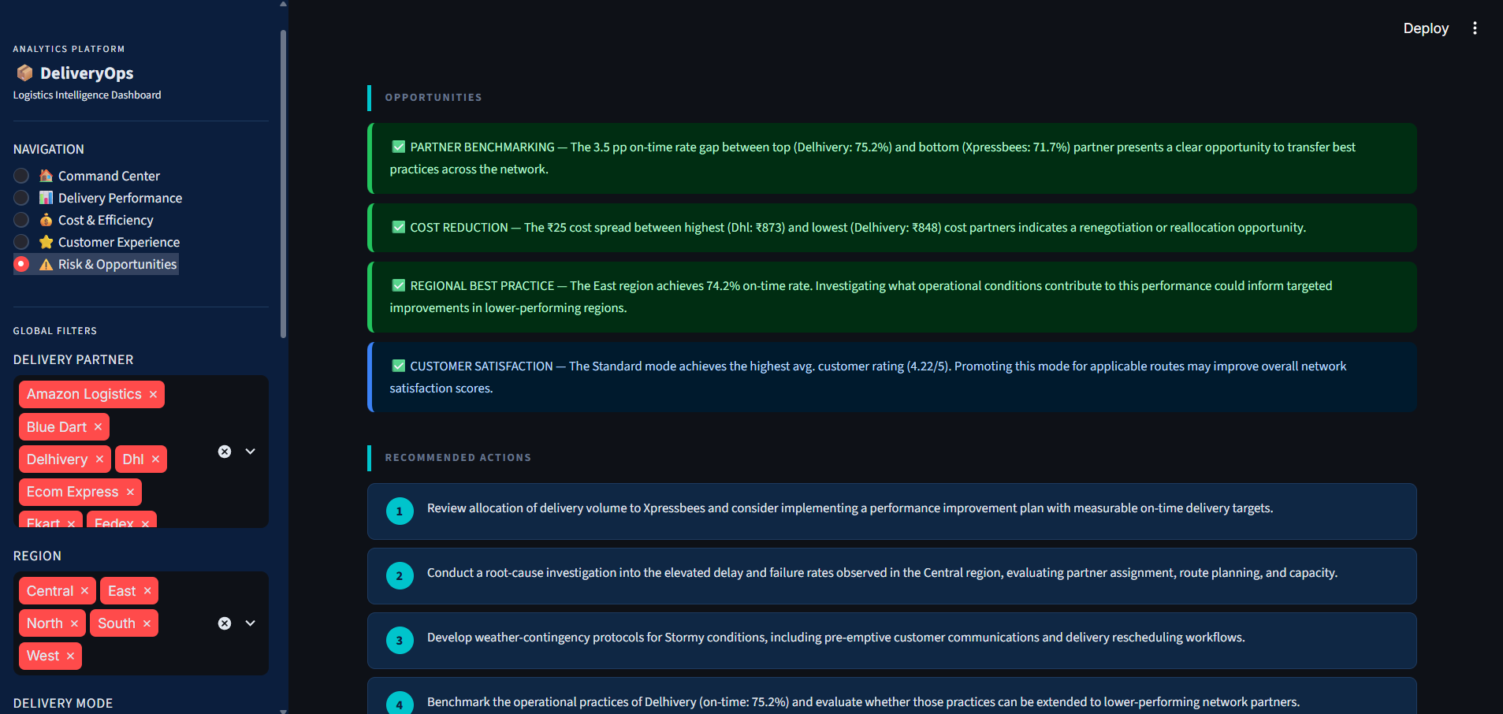
Picture 7:Risk & Opportunities1
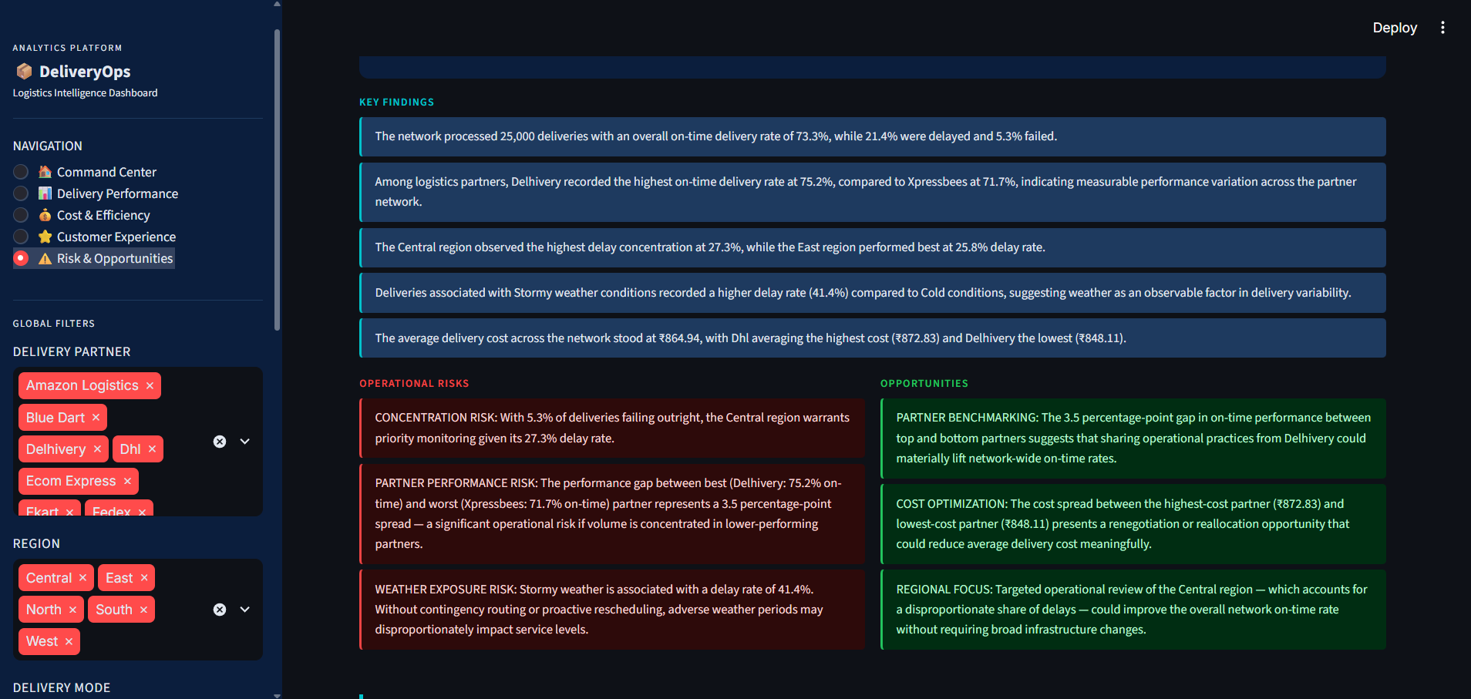
Picture 8 : Key Findings

19. Limitations
- No calendar date column — the dataset is cross-sectional; monthly/quarterly trend analysis is not possible.
- delivery_id is not a true primary key — 498 values appear more than once.
- Time columns required custom nanosecond decoding; values represent integer hours (not timestamps).
- No city-level geographic data is available; analysis is at region level only.
- No historical comparison is possible with a single cross-sectional dataset.

20. Conclusion
This analysis demonstrates a complete business analytics pipeline — from raw data inspection through cleaning, validation, feature engineering, KPI calculation, and multi-dimensional driver analysis — without relying on machine-learning models. All findings are grounded in verified, observable data. The interactive Streamlit dashboard enables management to explore performance by partner, region, delivery mode, vehicle type, weather condition, and package type in real time.
The analysis reveals measurable variation in on-time delivery rates, delivery costs, and customer satisfaction across the partner network and geographic regions. Five practical management actions have been identified, each directly connected to a verified data finding. These findings provide a data-driven foundation for operational planning, partner performance management, and cost optimization decisions.

21. Future Improvements
- Integrate a calendar date dimension to enable monthly/quarterly trend analysis.
- Add city-level geographic mapping for granular delivery routing analysis.
- Build a partner SLA scorecard with configurable on-time delivery thresholds.
- Connect to a live data feed for real-time operational monitoring.
- Add anomaly detection for cost spikes or delay surges.
- Integrate an LLM API for dynamic narrative generation based on live metrics.

